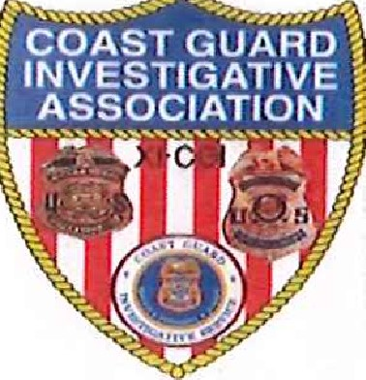
COAST GUARD INVESTIGATIVE ASSOCIATION (CGIA)
(ESTABLISHED 5/26/2005)

MEMBERSHIP APPLICATION
NAME:
DATE OF BIRTH:
ADDRESS:

PHONE:
EMAIL:
ELIGIBILITY REQUIREMENTS: |  | _____ New Graduate from CITP, SABT or ITP (circle one)
SERVED AS: |  | _____ CGIS (Director/DD/AD/SAC/ASAC/RAC/SA)  BRANCH CHIEF (oil/ole)  _____ SECURITY MANAGER  INVESTIGATING OFFICER
Training: |  | _____ OTHER (SPECIFY) __________  USAF OSI
______ FEDERAL LAW ENFORCEMENT TRG CENTER (FLETC)
______ TREASURY LAW ENFORCEMENT SCHOOL (TIES)

______ OTHER (SPECIFY) ______________________

INVESTIGATIVE DUTY ASSISGNMENTS (UNIT) DATES ASSIGNED

I certify the above information is true and correct and I served satisfactorily while assigned.

Signature Date
Forward completed application for review and acceptance, along with dues for two years in the amount of $50.00 to:
Jeff Kilpatrick, Secretary, CGIA, 549 Lake Drive, Ocala, Florida 34472-5050
Phone: (352) 239-0491 Email: jhkcgret@comcast.net

